The American College of Neuropsychiatrists (ACN)/The American College of Osteopathic Neurologists and Psychiatrists (ACONP)
presents

2024 Mid-Year Meeting and Scientific Seminar- Charleston, South Carolina

February 28-March 2, 2024
Hyatt Place and Hyatt House Hotels
560 King Street, Charleston, SC 29403

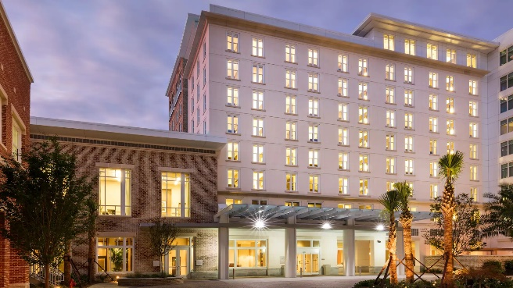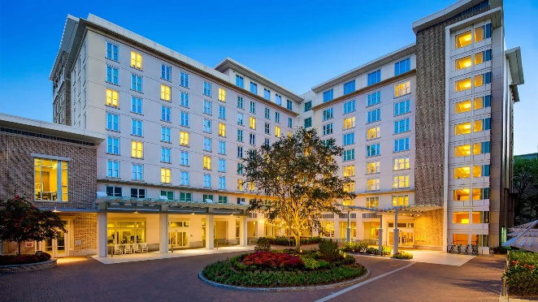
Hyatt House and Hyatt Place Hotels, Charleston, South Carolina
Both types of accommodations $279/night. If calling the Hyatt Phone 843-414-4900, use the code G-ACON for our room block. ROOM BLOCK RELEASED JANUARY 30, 2024
American College of Neuropsychiatrists - Hyatt House King Bed Suite ONLY
American College of Neuropsychiatrists - Hyatt Place King Bed or 2 Queen Bed Hotel Rooms

Meeting and Event Preliminary Schedule
25 hours 1A AOA Specialty CME Hrs. Anticipated

Wednesday, February 28 (8.5 hours) 8:00 am-4:45 pm
8:00 -9:00 am Remote Acute Outpatient and Inpatient Neuro-Critical Care Issues and Challenges in Standards of Care in the New Global Healthcare World-
Terry Himes, D.O.
9:00 -10:00 am Cannabis and Management in Outpatient Behavioral Health-
Todd Jamrose, D.O.
10:00-11:00 am Stress/Anxiety: Occupational Psychiatry Considerations-
Bascom Bradshaw, D.O., MPH, FAOCOPM, FACN
11:00 am-12:00 pm – CME Requirements-Sue Wesserling, MBA
12:00-1:00 pm- AOBNP Certification Updates- Shailesh Rajguru, D.O., FACN
1:15 pm-1:30 pm Exhibitor/Vendor Time
1:30-2:30 pm Great/Interesting Case-Adam Haikal, D.O.
2:30-3:45 pm Early Recognition of Parkinson’s Disease-
Wayne Ross, D.O., FACN
3:45-4:45 pm Osteopathic Way of Life-J. Scott Trayer, D.O.
5:00-5:30 pm General Membership Meeting

Thursday, February 29 (8.75 hours) 7:30 am-5:30 pm
7:30 -8:30 am Alzheimer’s Disease Update-K. Doug Pugar, D.O.
8:30-9:30 am Neuroleptic Malignant Syndrome
& Malignant Catatonia-Nora Burns, D.O.
9:30-10:30 am Sleep Disorders and Disturbances in Autoimmune Encephalitis-
Matthew Smith, D.O.
10:30 am-12:00 pm Stroke Treatment Update-
Suzanne Crandall, D.O.,EMBA, FACN
12:00 -12:15 pm Exhibitor/Vendor Time
12:15-1:00 pm Tentative Product Theater Lunch
1:00 -1:15 pm Exhibitor/Vendor Time
1:15-2:15 pm Headache Treatment Update-Richard Lukose, D.O.
2:15-3:15 The Role of Inflammation in Mental Health/Functional and Integrative Psychiatry- Jonathan Terry, DO, QME, ABIHM, IFMCP
3:15-4:15 pm Examination of Medical Student and Physician Attitudes Towards Suicide
Reveals Need for Required Training-Paulyna Schulz, MS & Teodor Huzij, D.O., FACN
4:15-4:45 pm Great/Interesting Case-Irfath Khan, D.O.
4:45-5:15 pm- Great/Interesting Case-Tsedey Biru-Williams, D.O.
5:15-5:30 pm Poster Board Presentation and Competition
6:00 pm Reception/Dinner, Fellowship Ceremony, Poster Board Awards, Tribute in Memory of Louis E. Rentz, D.O., D.FACN

Friday, March 1 (6 hours) 7:45 am-3:15 pm
6:30 -7:30 am Tentative Product Theater Breakfast
7:30 -7:45 am Exhibitor/Vendor Time
7:45 -8:45 am Longevity-Nicole Barylski Danner, D.O., FACN
8:45-9:45 am Antibodies for Encephalitis Presenting as Psychiatric Disorder-
Anne M. Pawlak, D.O., D.FACN, FAAN
9:45-10:45 am New Monoclonal Antibody Medications-
Aaron Ellenbogen, D.O.,MPH, FACN
10:45 -11:45 am Mimics of Cervical Radiculopathy Part I-
David A. Simpson, D.O., D.FACN, FAANEM, FAAN
11:45 am-12:00 pm Exhibitor/Vendor Time
12:00 – 1:00 pm Tentative Product Theatre Lunch
1:00 pm-1:15 pm Exhibitor/Vendor Time
1:15-2:15 pm Mimics of Cervical Radiculopathy Part II-
David A. Simpson, D.O., D.FACN, FAANEM, FAAN
2:15-3:15 pm Addiction in Women’s Health-Nora Burns, D.O.
3:15 pm-3:30 pm Exhibitor/Vendor Time

Saturday, March 2 (3.75 hours) 7:30 am-11:15 am
7:30 -8:45 am- Dementia with Lewy Bodies-Christian White, D.O.
8:45-10:00 am Brachial Plexopathies- Jeffrey Esper, D.O., D.FACN
10:00-11:15 am Multiple Sclerosis Update-Kenneth Mankowski, D.O., FACN

Registration:
Non-Member $800.00
Member (Dues Paid) $625.oo
Retired, Resident & Allied Prof. (MD,RN, NP, Etc.) $400.00

No Refunds after February 1, 2024

Please contact the ACONP office or complete the registration form to register:
acn-aconp@msn.com
or call (248) 553-6207

